Abstract title

Author(s) name ^{(affiliation number)}: corresponding Author and Co-authors

(affiliation number)Author(s) affiliation

email_corresponding author@mail_server

The thematic is focused on the relationships between geological constrains and the triggering, evolution and problems associated to large landslides. The Committee will only consider abstracts that fulfill with the main topics of the event. Please use no more than 500 words and maximum one figure. Including the figure, the abstract should be limited to one single page.
Text format: Arial, 11 pt, space between lines 13 pt, justified, one column, indentation 0 mm. Citations in text: e.g., Cruden (1976), Evans and Hungr (1993), Dal Piaz et al. (2003). Figures must be centered. Figures can be in color or in B&W. Letter size minimum is 8 pt. Minimum quality of 300 dpi. Figures caption below the figure (caption text format: Arial, italic, 10 pt).

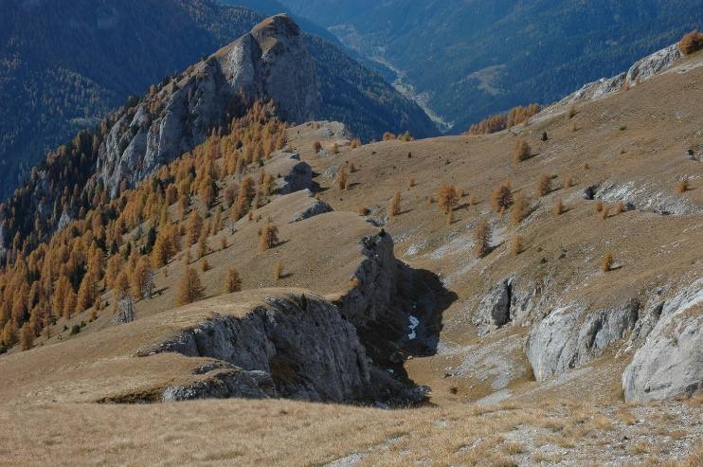
Figure 1 Figure title. Figures with resolution no less than 300 dpi.

Cruden, D. M. (1976). “Major rock slides in the Rockies”. Canadian Geotechnical Journal, 13(1): 8-20.
Evans, S.G. and Hungr, O. (1993). “The assessment of rockfall hazard at the base of talus slopes”. Canadian Geotechnical Journal, 30: 620–636.
Dal Piaz, G. V., Bistacchi, A., Massironi, M. (2003). “Geological outline of the Alps”. Episodes, 26(3): 175-180.

